Project Design Phase
Proposed Solution

Date | 02 November 2025
Team ID | NM2025TMID00562
Project Name | Laptop Request Catalog Item
Maximum Marks | 2 Marks

S.No. | Parameter | Description
1. | Problem Statement (Problem to be solved) | In many organizations, laptop requests are handled manually through emails or verbal communication, causing delays, confusion, and mismanagement. Employees have no visibility into the approval or delivery status, and IT teams struggle to track pending requests efficiently.
2. | Idea / Solution Description | Develop a Laptop Request Catalog Item in ServiceNow that allows employees to easily submit requests for laptops through a structured form. The request automatically routes to the employee’s manager for approval and then to the IT support team for fulfillment. Notifications are sent at every stage to ensure transparency and accountability.
3. | Novelty / Uniqueness | The solution leverages ServiceNow’s native Catalog and Flow Designer features to create an end-to-end automated process without external dependencies. It reduces manual workload, ensures accurate data entry, and provides real-time visibility into every request.
4. | Social Impact / Customer Satisfaction | It improves workplace efficiency and satisfaction by minimizing delays, providing real-time updates, and ensuring that employees get the required laptops faster. IT staff benefit from organized task management and reduced miscommunication.
5. | Business Model (Revenue Model) | While not directly revenue-generating, the solution significantly saves time and resources. It optimizes IT operations, reduces manual tracking costs, and supports sustainable digital transformation for enterprises.
6. | Scalability of the Solution | The solution can be easily scaled to include other hardware or asset requests (e.g., monitors, accessories, or mobile devices). It can also integrate with CMDB (Configuration Management Database) for tracking issued assets and inventory.

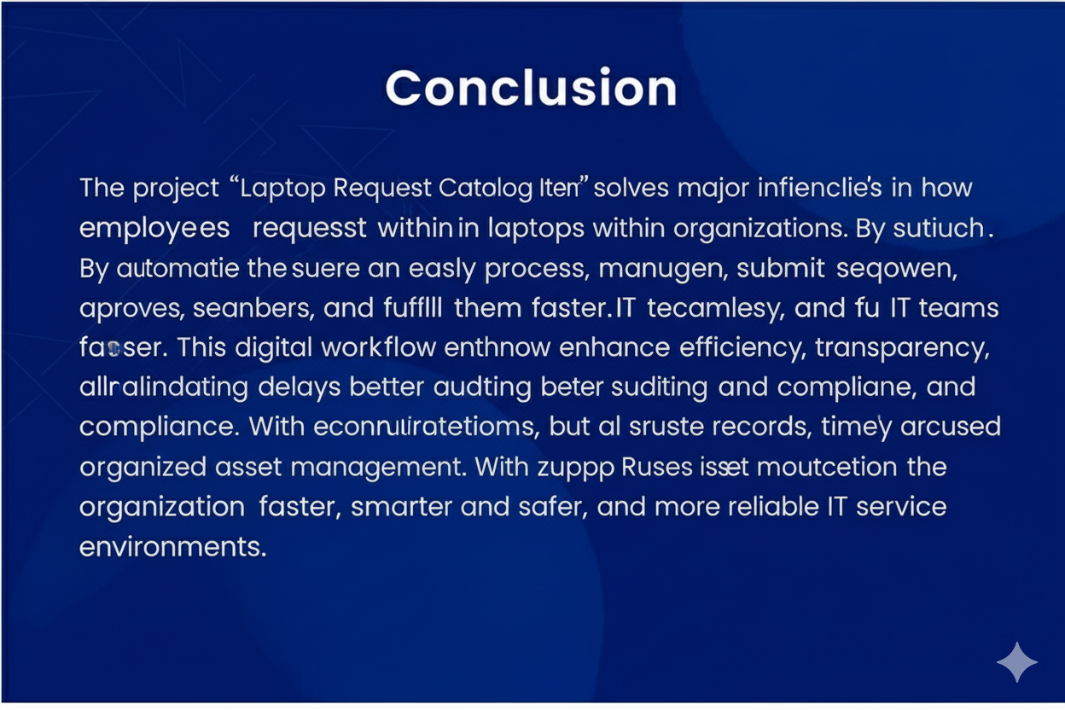

Solution Description

To simplify and automate the process of requesting laptops in ServiceNow, a custom Service Catalog Item is created.
This catalog form allows employees to submit laptop requests by specifying details such as laptop type, RAM, storage, and justification.
A Flow Designer workflow is configured to automatically route the request for manager approval and then assign it to the IT support team for fulfillment.
At each stage, email notifications are triggered — informing the requester, manager, and IT staff of the current status.
This approach leverages native ServiceNow features like Catalog Items, Approvals, and Flow Designer, making it simple, efficient, and plugin-free.
The solution improves operational efficiency, ensures timely approvals, enhances communication, and provides full transparency in the laptop request and delivery lifecycle.

